|  |  |  |
| --- | --- | --- |
| aecom_imagineit_1mm_border_v1  Julia Robins  Bakerloo Line Extension Planning Manager  London Borough of Lewisham |  | AECOM Infrastructure & Environment UK Limited  2 Leman Street, London E1 8FA  Telephone: 020 7061 7000  aecom.com    21 October 2019 |
| **New Cross Gate Supplementary Planning Document (SPD): SEA Screening Opinion** | | |
|  | | |
| Dear Julia | | |
|  | | |

The London Borough of Lewisham (LBL) has asked AECOM to provide a Strategic Environmental Assessment (SEA) Screening Opinion in respect of the New Cross Gate SPD. This letter presents our Screening Opinion.

**Background**

The aim of the SEA Directive (2004/42/EC) is as follows: *“to contribute to the integration of environmental considerations into the preparation and adoption of plans and programmes with a view to promoting sustainable development, by ensuring that an environmental assessment is carried out* ***of certain plans and programmes which are likely to have significant effects on the environment.****”*

In order to decide whether an SPD is likely to have significant environmental effects, and hence requires SEA, it should be ‘screened’ at an early stage, i.e. once the scope of the SPD has been established.

**Who is responsible for screening?**

The SEA Regulations, which transpose the SEA Directive into law, state that a screening determination should be reached by ‘the responsible authority’, which, in this case, is London Borough of Lewisham.

The Council should reach a determination in-light of this screening opinion, and in consultation with the statutory consultation bodies designated under the Environmental Assessment of Plans and Programmes Regulations 2004 (the SEA Regulations) (Natural England, the Environment Agency and Historic England).

**Screening methodology**

Screening essentially involves giving consideration to the anticipated scope of the plan in question and the nature of environmental issues locally, before coming to a conclusion on the potential for a cause-and-effect relationship, i.e. the likelihood of the plan leading to ‘significant effects on the environment’.

Schedule 1 of the SEA Regulations lists a series of criteria that should be taken into account when establishing the potential for the plan to result in significant effects. Furthermore, Schedule 2 lists a series of broad environmental issues that should be considered. The criteria/issues listed in the Regulations are helpful in that they provide a methodological basis for screening.

Finally, there is a need to note the following Planning Practice Guidance (with emphasis added):[[1]](#footnote-1)

*“Supplementary planning documents do not require a sustainability appraisal but may in* ***exceptional circumstances*** *require a strategic environmental assessment if they are likely to have significant environmental effects that have not already have been assessed during the preparation of the relevant strategic policies.*

*A strategic environmental assessment is unlikely to be required where a supplementary planning document deals only with a* ***small area*** *at a local level, unless it is considered that there are likely to be significant environmental effects.”*

**The emerging New Cross Gate SPD**

The aim of the New Cross Gate SPD is to supplement the adopted Lewisham Local Plan by providing additional guidance to help ensure that forthcoming developments at New Cross Gate are planned in a coherent way and deliver a high-quality built environment and public realm. The area covered by the SPD comprises New Cross Gate station and surrounding land – see **Figure 1**.

*Figure 1: The area covered by the SPD*

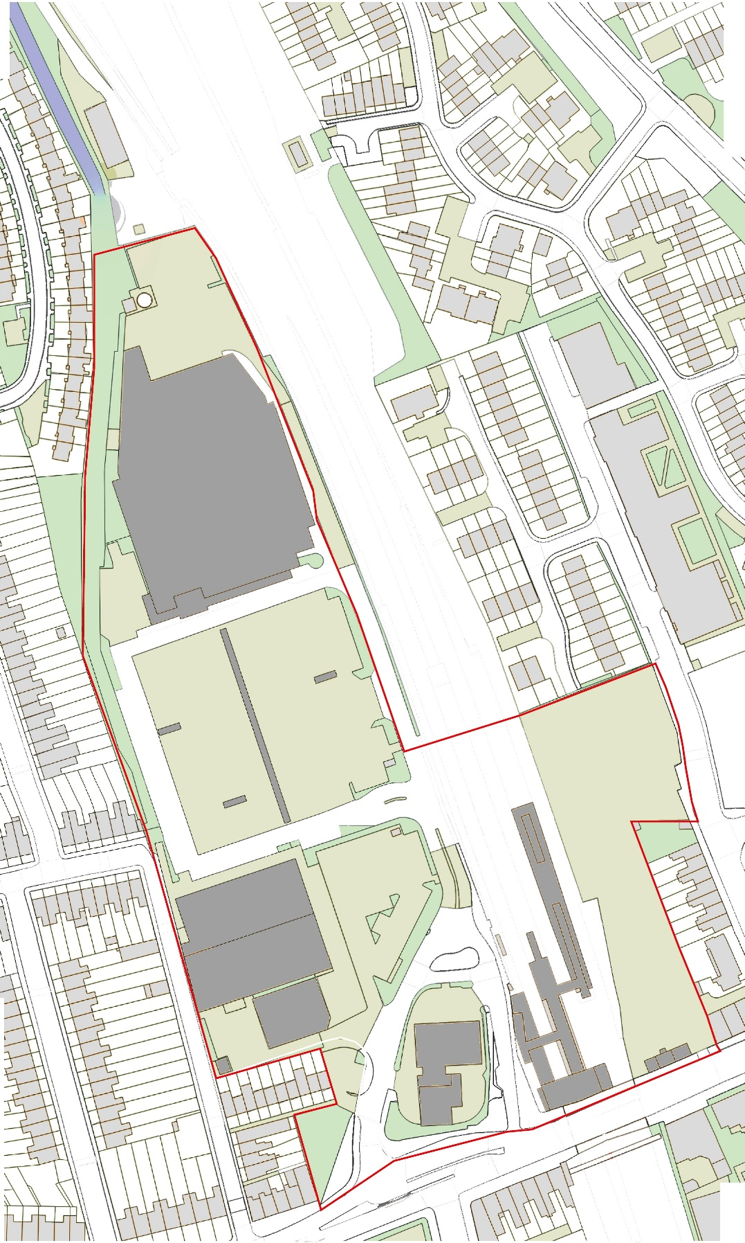

The SPD area is bisected by railway lines running through the site, with allocated development sites either side of the railway. Specifically, the Site Allocations Local Plan (2013)[[2]](#footnote-2) allocates:

* Hatcham Works (west of the railway) – allocated for c.200 homes along with retail, community facilities and a new station and public space; and
* Goodwood Road (east of the railway) – allocated for c.148 homes plus retail and business uses.

There has been developer interest in the two sites within the SPD area, and planning applications are expected to come forward for both sites in the near future. The aim of the SPD is to supplement the established site allocation policy, with a view to fully realising opportunities, understanding of which has evolved significantly since 2013, and addressing constraints.

The net effect is that the SPD is aiming to support a more intensive use of the two sites than anticipated in the Site Allocations Local Plan, with new proposed yields of c.1,100 new homes for the Hatcham Works site and c.260 new homes for the Goodwood Road site.

The SPD will conclude by presenting an illustrative masterplan, a draft version of which is presented below – see Figure 2 – with the Draft SPD describing key components of the masterplan as follows:

1. Two-sided streets designed to accord with the Mayor’s Healthy Streets Approach, bounded by active ground floor uses and frontages onto the street.
2. New buildings to sensitively reinforce the high street, bridging the current gap across the front of this site.
3. Large grocery food store brought to front of the site to improve vitality and viability of New Cross district centre and strengthen the shopping frontage. Also by bringing buildings to the frontage it re-knits the built form and provides activity.
4. Route 1 to continue across the site, with new bridge over the railway tracks and ramps integrated into the streetscape with emphasis on creating high quality, attractive environment for pedestrians and cyclists. Footbridge and surrounding buildings to be configured to enable long views along adjacent streets.
5. New north south connection made on Hatcham Site. This follows the existing ladder of streets in New Cross.
6. Opportunities across the site to locate commercial uses, on Route 1 and Goodwood Road.
7. Buildings of height located away from sensitive New Cross Road frontage and low rise neighbouring properties. Height has been placed back from the high street close to the new Route 1 connection as it takes advantage of the topography so the buildings cannot be easily seen behind the frontage buildings on New Cross Road;
8. Scale and mass of buildings shows respect for surrounding context which in many places has a fine grain.
9. Buses to remain within the site with a turning head in the northern part of the Hatcham Works site.
10. New junction on New Cross Road to be designed to accommodate cycle facilities and pedestrian crossings outside the station. These improvements are required in order to re-balance the street enabling, New Cross to fulfil its role as a district centre and safe pedestrian environment, while also maintaining traffic flow.
11. Mixed-use development on the Goodwood Road site. New residential development to be provided alongside significant commercial floorspace, serviced at street level from Goodwood Road. Detailed proposals for this site to balance overall quantum of development with the massing constraints imposed by the site, which is bounded to the north and east by existing housing vulnerable to overshadowing.
12. Retained retail uses and new development on Goodwood Road to support use of Goodwood Road as extension of the high street.

It is also important to note the proposed approach to height, scale and massing, with the draft SPD explaining that:

*“Given its location within a Regeneration and Growth Area tall buildings are suitable within the SPD Area (as confirmed in Core Strategy Policy 15). However tall must be considered in the local context and the prevailing context is primarily between 2-4 storeys occasionally interspersed with buildings which are taller; although those taller elements do not exceed 10 storeys.*

*The following methodology was applied to establish a heat map which identifies where taller buildings can be located in the SPD area:*

*1.Understand and take into account the topography;*

*2.Identify important views and locations where the heritage asset and its setting could potentially be impacted;*

*3.Test height scenarios through 3D modelling;*

*4. Identify sensitive relationships with surrounding low rise residential properties*

*5. Identify key routes and connections as places which may be suitable to place a taller building*

*… Through testing the location and height of tall buildings in the SPD Area height ranges and locations where a tall building have been established and are shown on the heat maps.*

*Massing is another important consideration as blocks which are too large can also adversely affect light penetration to spaces around buildings. As such if they are located to the south of public spaces or private amenity areas they should be reduced in height that will ensure sufficient sun and day light exposure into open areas.*

*The key urban design principles for any schemes coming forward in the SPD are in relation to height, scale and massing are as follows:*

*• The scale and massing of buildings must respond to positively to the character of the adjacent conservation areas, existing residential environments and New Cross Road;*

*• Tall buildings must be sited in the locations identified as suitable on the heat map;*

*• Tall or large buildings should not cause harm to existing residential environments and their amenity;*

*• Tall buildings must be positioned in locations which are logical and legible and on key routes;*

*• Tall buildings must be informed by an assessment of views at local and cross London levels, as identified in Lewisham’s Local Plan and the London View Management Framework…;*

*• The scale and massing of buildings must provide an appropriate transition in scale between taller elements and the areas surrounding heritage assets which are typically 2 to 4 storeys*

*• Buildings of height must be positioned so that there is daylight and sunlight penetration to open spaces and public realm so that they are fit for purpose and are useable, pleasant spaces for long periods during the day. Siting tall buildings to south of open spaces where they are in shadow for long periods of day should be avoided.*

*• In terms of the building itself a tall building must comprise… Lower floors: active frontages with a mixture of uses and clear entrances; Middle floors: articulated façade, balconies/winter gardens, vertical expression, façade proportion and modelling; Upper floors: opportunities for varying the building line with setback/frame*

*• Architecture of buildings must be varied to provide interest but there should be some common language between buildings to create a cohesive development.”*

*Figure 2: The draft illustrative Masterplan*

****

**Relevant environmental issues locally**

Heritage is a key environmental constraint locally, with much of the built history of New Cross and Deptford protected by various heritage designations, including designated conservation areas and nationally listed buildings. Although there are no nationally listed (or locally listed) buildings within the SPD area there remains the potential to impact on the setting of certain listed buildings. The Hatcham Conservation Area (CA) intersects the southern-most part of the SPD area, whilst the Telegraph Hill CA is adjacent to the south and the Deptford Town Hall adjacent to the southeast.

Other key environmental issues relate to transport / movement and use of the public realm, along with associated CO2 emissions, air pollution and health implications. The following is a summary:

* Public transport – this is one of the most accessible locations within the Borough; however, the existing station building is not large enough for the current volume of passengers; and the narrow footway outside the station is overcrowded, particularly around bus stops.
* Pedestrian movements - the level changes between the Hatcham Works site and surrounding streets have resulted in poor connectivity. Where connections have been made, such as the ramp between Hatcham Park Road and the Hatcham Works site, these are of poor quality.
* Cycling – a lack of cycle infrastructure causes issues outside the station as cyclists use the footway.
* Traffic - the existing station at New Cross Gate is the busiest in the area and becomes congested.
* Urban realm - the New Cross Road frontage to the south of the SPD area forms a fragmented frontage to New Cross Road, which is out of character with its town centre location, and there is a lack of active uses on the high street. The public realm across the front of the SPD area is traffic dominated and of poor quality; the supermarket has a large car park that is underused, and creates a hostile environment for pedestrians.

There is the potential to address a number of these issues through the SPD, notably:

* Joining disconnected sections of the high street would increase activity, creating more space for businesses and improving the street environment for pedestrians.
* A development on both sites offers the opportunity to complete Bus Route 1 by connecting into existing streets at Hatcham Park Road and to Goodwood Road and Batavia Road via a footbridge and routes across both sites.
* New routes across the Hatcham Work site for cyclists, wheelchair users and prams would establish a street level connection to neighbourhoods that lie north west of the site.
* The Hatcham works site is long and narrow and provides the opportunity to create a new north south route.

Finally, there is a need to consider the opportunity associated with the potential Bakerloo Line Extension. TfL has chosen the Hatcham Works site as the preferred location for a new station and construction site, hence applications for the site would need to plan proactively for the BLE and respond to the timescale / programme of the BLE. The SPD aims to facilitate this process.

**Screening analysis** (N.B. Further information is presented in **Appendix 1**)

There are significant heritage sensitivities locally, such that the SPD proposal in respect of support for more intensive development (of the Hatcham Road site in particular), relative to the approach to development supported through the adopted Site Allocations Local Plan, leads to a degree of tension with heritage objectives. However, detailed work has been completed in respect of ensuring a targeted approach to building heights, massing and design that responds to the constraints that exist.

There are also transport issues locally; however, there will be much potential to deliver new and improved transport infrastructure through redevelopment of the site.

**Conclusion (Screening Opinion)**

In conclusion, it is not considered likely that the SPD will lead to significant effects on the environmental baseline situation, which is one whereby the two sites within the SPD area are redeveloped in accordance with policies SA5 and SA6 of the Site Allocations Local Plan.

The effect of the SPD will be to support a significant increase in the quantum of new homes delivered in the area, and more generally a more intensive form of redevelopment with taller buildings and increased massing; however, this is a relatively small area of land, and there is good potential to avoid and mitigate effects through policy. Furthermore, there will be good potential to modify the plan following consultation, to reflect any concerns raised, including any concerns raised in respect of heritage.

There would be little to be gained by formal assessment of alternatives and the emerging draft SPD against a systematic framework of environmental issues/objectives (i.e. SEA). As such, our recommendation is that the Plan is ‘screened-out’, i.e. need not be subject to SEA.

**Next steps**

London Borough of Lewisham, as the responsible authority, should give consideration to this screening opinion, consult with the Statutory Consultees (Natural England, Historic England and the Environment Agency) and then reach a screening determination.

If the plan is ultimately screened-out, then plan-making may continue without having to give further consideration to SEA requirements; however, if it is ultimately determined that SEA is required, there will be a need to undertake SEA in accordance in accordance with the regulatory requirements.

Finally, it is important to note that our screening opinion is based on a series of assumptions, most notably in relation to the scope of the plan. If the scope of the plan changes, such that these assumptions no longer hold true, then ‘re-screening’ could be necessary.

Please do get in touch with any queries regarding this SEA screening opinion, or next steps.

Yours sincerely

for **AECOM** **Infrastructure & Environment UK Limited**

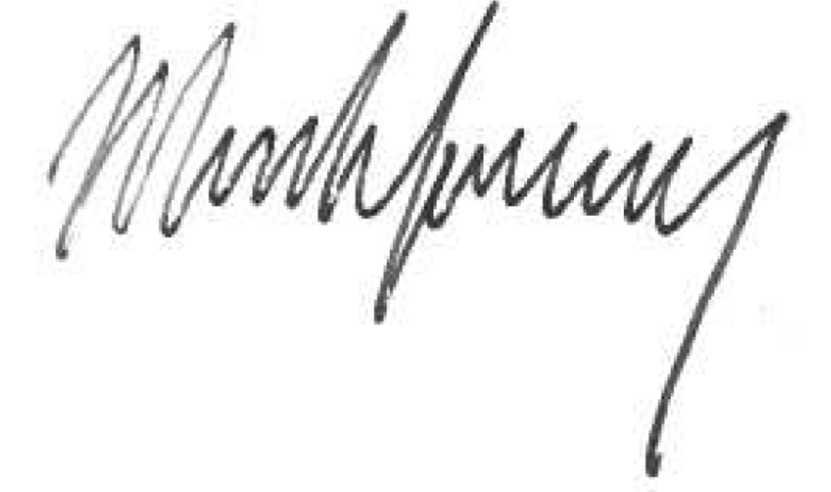

Mark Fessey

Associate Director

[Mark.fessey@aecom.com](mailto:Mark.fessey@aecom.com)

**Appendix 1: Regulatory checklist**

As discussed above, under ‘Screening methodology’, Schedule 1 of the SEA Regulations lists a series of criteria that should be taken into account when establishing the potential for the plan to result in significant effects. The aim of this appendix is to discuss matters under each criterion in turn.

| **Criteria** | **Significant effect?** | **Discussion** |
| --- | --- | --- |
| ***1. The characteristics of the SPD, having particular regard to:*** | | |
| (a) the degree to which the SPD sets out a framework for projects and other activities, either with regard to the location, nature, size and operating conditions or by allocating resources. | No | The SPD does aim to set a framework for planning applications; however, this consideration in and of itself does not serve to suggest the likelihood of significant effects. |
| (b) the degree to which the SPD influences other plans and programmes including those in a hierarchy | No | The SPD is not likely to have a significant bearing on the preparation of other plans or programmes, although there could be implications for the Bakerloo Line Extension. |
| (c) the relevance of the SPD for the integration of environmental considerations in particular with a view to promoting sustainable development | No | The SPD seeks to respond to a range of environmental constraints and opportunities, perhaps most notably in respect of heritage, views / townscape and transport/movement. However, these issues/opportunities are of limited significance. |
| (d) environmental problems relevant to the plan or programme | No | In addition to the heritage constraints discussed above, it is fair to conclude that there are issues/problems in respect of the public realm and transport connectivity locally. However, these problems are of limited significance. |
| (e) the relevance of the plan for the implementation of Community legislation on the environment (for example plans and programmes related to waste management or water protection) | No | It is not anticipated that the SPD will have a notable bearing, in this respect. |
| ***2. Characteristics of the effects and of the area likely to be affected, having regard, in particular,*** | | |
| (a) The probability, duration, frequency and reversibility of the effects | No | The effects of the plan will be felt over the long term, and will be for all intents and purposes irreversible; however, this does not in itself lead to a conclusion that effects will be significant. |
| (b) the cumulative nature of the effects | No | The SPD will be implemented alongside the Local Plan and the London Plan, and so there will be a cumulative effect; however, this does not in itself lead to a conclusion that effects will be significant. |
| (c) the trans boundary nature of the effects | No | No relevant; no international effects on other EU member states. |
| (d) the risks to human health or the environment (e.g. due to accident) | No | Environmental quality and environmental health are matters relevant to the SPD; however, the SPD is not likely to lead to any risks. |
| (e) the magnitude and spatial extent of the effects (geographical area and size of the population likely to be affected) | No | The key point to note is in respect of the magnitude of the increase in housing quantum supported by the SPD, and support for taller buildings and increased massing with a bearing on the surrounding area; however, these factors do not in themselves serve to suggest that effects will be significant. |
| (f) the value and vulnerability of the area likely to be affected due to:   * Special natural characteristics or cultural heritage * Exceeded environmental quality standards or limit values * Intensive land use | No | There are number of constraints in the local area, most notably in respect of heritage, with one conservation area intersecting the southern-most part of the SPD area and two further conservation areas adjacent. In respect of landscape there are protected views, but these are not of national significance. Overall, the special characteristics etc. of the local area do not suggest the likelihood of significant effects. |
| (g) the effects on areas or landscapes which have a recognised national, Community or international protection status | No |

1. See paragraph 8 at: <https://www.gov.uk/guidance/strategic-environmental-assessment-and-sustainability-appraisal> [↑](#footnote-ref-1)
2. See <https://lewisham.gov.uk/myservices/planning/policy/ldf/site-allocations/site-allocations-local-plan> [↑](#footnote-ref-2)