London Borough of Lewisham

## LIP3

## Appendix D: Collision Analysis

## September 2018

DRAFT

1. Background 1

2. Vision Zero 2

3. General overview/trends 4

4. Analysis by mode 6

5. Collision types 12

6. Fatalities 14

7. Where casualties occurred 15

8. Casualty Analysis Summary 19

9. Achieving Vision Zero 21

# Background

Casualty data for the calendar years of 2012-2016 has been reviewed in order to provide an understanding of the underlying patterns and trends in the London Borough of Lewisham (LBL).

Collection methods for collision and casualty data in London altered in 2017 and some compatibility issues, particularly associated with how serious casualties have been recorded (compared with the pre 2017 STATS19 data), are still being resolved by the data provider. As a result, for the purposes of this note, it was considered necessary to only consider the data which can be currently verified and directly compared with previous years (trend identification). As further work on this takes place, this note will be updated for inclusion with the final Transport Strategy and Local Implementation Plan 2019-2041 document.

Despite not including casualty data from 2017 and 2018, the 2012-2016 data sample is still considered very relevant in terms of the expected collision patterns and will provide a robust assessment of casualty patterns that currently exist on the LBL network.

# Vision Zero

The Mayor’s Transport Strategy 2018 (MTS) sets out a bold vision for reducing ‘road danger’ with a series of targets and interim targets under the banner of ‘Vision Zero’. The main targets are summarised as:

* To reduce the number of people killed or seriously injured (KSI) by 65% compared with 2005-2009 levels by the year 2022
* To reduce the number of people KSI in/by buses to zero by the year 2030
* To reduce the number of people KSI by 70% compared with 2010-2014 levels by the year 2030
* To reduce the number of people KSI to zero on London’s roads by the year 2041
* There is a particular emphasis within the MTS on reducing risk to vulnerable road users such as pedestrians, cyclists and motorcyclists - complementing the overarching transport objective of reducing car use (and vehicle emissions) within London by creating safe, attractive streets and places for healthy, clean modes.

Table 2.1 – Casualty numbers in LBL (2005-2016) and future ‘Vision Zero’ targets

|  |  |  |  |  |  |  |
| --- | --- | --- | --- | --- | --- | --- |
| Year | Total | Fatal | Serious | KSI | Vision Zero Targets (KSI Casualties) | |
| 2005 | 1087 | 6 | 139 | 145 | 44 | reduction of 65% of 2005-2009 average by 2022 |
| 2006 | 1019 | 2 | 130 | 132 |
| 2007 | 880 | 6 | 118 | 124 |
| 2008 | 880 | 3 | 110 | 113 |
| 2009 | 972 | 7 | 105 | 112 |
| 2010 | 938 | 3 | 105 | 108 | 26 | reduction of 70% of 2010-2014 average by 2030 |
| 2011 | 1064 | 3 | 100 | 103 |
| 2012 | 998 | 3 | 99 | 102 |
| 2013 | 940 | 6 | 58 | 64 |
| 2014 | 1039 | 7 | 56 | 63 |
| 2015 | 1013 | 2 | 51 | 53 |  | |
| 2016 | 1050 | 2 | 65 | 67 |
| *2017 | 1111 | 7 |  |  |

* 2017 casualty numbers are provided for information purposes but for the reasons noted in Section 1 (that particularly concern KSI casualty numbers) have not been considered in the numerical/trend analysis

Table 2.1 illustrates that, in order to adhere to Vision Zero targets outlined in the MTS, LBL must achieve a level of KSI casualties at or below 44 by 2022 and at or below 26 by 2030.

The data in Table 2.1 indicates a notable drop in the level of serious casualties recorded from 2013 onwards, though at this stage the reason for this is unclear. This was a pattern experienced in many Inner London boroughs and discussions with Transport for London (TfL) have not indicated any attributable reason for this at this stage. Notwithstanding this, LBL will need to reduce KSI casualties by a further 23 compared with 2016 levels by the year 2022 to achieve the first ‘Vision Zero’ target.

With the emphasis within MTS being to provide clean, healthy and safe environments for modes other than motor vehicles, the data contained within this note will focus mainly on vulnerable road user modes (pedestrians, motorcyclists and cyclists) and will provide an evidence base to assist with the development of a ‘Vision Zero approach’ for LBL - feeding into the development of the LIP3 submission to TfL.

# General overview/trends

## By year

A total of 5,040 casualties were recorded in LBL between 2012 and the end of 2016 – including 329 serious casualties and 20 fatalities. Table 3.1 below provides a summary of the casualties recorded by year and for the purposes of further analysis, the five year data sample has also been split into separate six-month periods.

The data is also provided on a scatter plot (Figure 3.1) in order to aid visualisation of any trends.

Table 3.1 – Casualty trends by year (LBL)

|  |  |  |  |  |  |  |
| --- | --- | --- | --- | --- | --- | --- |
| Year | Period | Slight | Serious | Fatal | Total | Rolling 24 month average |
| 2012 | 1 | 441 | 57 | 1 | 499 | - |
| 2 | 455 | 42 | 2 | 499 | - |
| 2013 | 3 | 378 | 27 | 3 | 408 | - |
| 4 | 498 | 31 | 3 | 532 | 485 |
| 2014 | 5 | 498 | 29 | 3 | 530 | 492 |
| 6 | 478 | 27 | 4 | 509 | 495 |
| 2015 | 7 | 421 | 25 | 1 | 447 | 505 |
| 8 | 539 | 26 | 1 | 566 | 513 |
| 2016 | 9 | 511 | 18 | 0 | 529 | 513 |
| 10 | 472 | 47 | 2 | 521 | 516 |
| 2017 | 11 |  |  | 5 | 537 | 538 |
| 12 |  |  | 2 | 573 | 540 |

Note: 2017 Slight and serious casualties not verified

Figure 3.1 – Casualty trends by six month period (LBL)

Figure 3.1 indicates a slight rising trend in the number of casualties in LBL between 2012 and 2016 (displayed in 10 equal six-month periods). The rolling average of three time periods (equating to 18 months) is also provided as this helps to smooth fluctuations from the data and helps to provide clarity when assessing any trends.

Casualty numbers have tended to fluctuate during the study period. However, based on the observed trend, the 18 month rolling average is projected to lie between 509 and 601 casualties (with 95% confidence[1]) at the end of June 2018.

# Analysis by mode

The MTS pays particular attention to ‘road danger’ associated with vulnerable road users such as pedestrians, cyclists and powered two wheelers (P2W). As such the analysis below focuses on these modes.

## General trends

Table 4.1 and Figure 4.1 below show the number of casualties that have occurred in LBL during the study period by mode.

Table 4.1 – Casualty data by mode (LBL)



Figure 4.1 – Casualty trends by mode (LBL)

The data above indicates the following:

* There was a steady decline in the occurrence of KSI casualties during the study period (2012-2016) – *this has been a general trend repeated in many other Inner London Boroughs* – though the levels did increase during the last 6 months of 2016;
* There has been a general decline in the number of casualties involving pedal cyclists during the study period (2012-2016);
* There has been a general increase in the number of casualties involving P2Ws during the study period (2012-2016) – albeit with some fluctuation;
* The number of pedestrian casualties has fluctuated with no obvious trend during the study period.

Table 4.2 below shows the modal casualties along with indications of the Chi-Squared significance of each category – compared to Inner London levels during the same period. Only data up until the end of 2016 has been included in Table 4.2 due to issues previously noted with the 2017 KSI data. This will not affect the overall understanding of current trends in LBL.

Table 4.2 – Casualty data by mode (LBL)



*Note: Control data for the Chi-squared tests was taken as all casualties in Inner London minus LBL.*

The data in Table 4.2 indicates that the proportion of casualties for vulnerable modes in LBL has largely been significantly below the levels experienced in other Inner London areas.

However, this is primarily considered to be a function of the prevailing conditions in LBL. For example, the modal split of cyclists in LBL is currently estimated at 3-4% (based on selected DfT count sites and Travel in London Report 10). Different sections of the highway network experience different cycling volumes and this also varies by time of day. To provide context, some routes in other central/inner London boroughs experience up to 30% (and above) cycle traffic during the morning peak, as a result of the presence of major Cycle Super Highway routes.

Such differences in the volume of cyclists present on the network will inevitably result in differences in casualty numbers – and is not necessarily a reflection of underlying risk. This needs to be considered carefully as proposals for major interventions such as new Cycle Super Highways and Quietways are considered.

The balance of all objectives will be considered therefore as LBL safety plans are developed- with attention paid to different approaches to promoting safe cycling including Quiet Ways and Quiet Street solutions that can achieve an increase in active travel modes away from busy heavily trafficked roads where road danger levels tend to be higher (unless segregated facilities have been introduced).

P2W casualty numbers also appear below Inner London levels. However, the trend is rising and this will be a key focus of attention in the coming years for LBL.

A total of 349 casualties resulted in a fatality or serious injury. Of these, 26% involved a P2W rider, 21% involved a cyclist and 34% involved a pedestrian – as shown in Table 4.3 below.

Table 4.3 – KSI casualty data by mode (LBL)



## Road danger/risk

Safe Streets for London (The Road Safety Action Plan for London 2020) advocates the concept of assessing road safety performance beyond absolute casualty numbers alone by considering them alongside other measures such as trip/journey data. Such an approach helps to add extra context to the data and provides a different insight based on risk/exposure levels.

For the purposes of this report, a metric is proposed that attempts to achieve a simple way to assess the LBL data in a similar manner by considering casualty percentages against ‘expected values’ such as estimated modal splits or demographic measures with a resultant ‘Risk Index’ figure as follows:

Risk Index (RI) = Observed Frequency (Collision %) / Expected Frequency (e.g. Modal Split %)

Table 4.4 – KSI casualty data by mode (LBL)



*\*Estimates based on data in Travel in London Report 10 and selected DfT count sites*

The figures in Table 4.4 indicate that the cycle casualties exhibited a level most out of line with expected levels and emphasises the need to continue to focus safety resources on cycling despite levels of casualties that appear lower than Inner London as a whole.

P2W casualties also exhibited a high RI and, coupled with the rising numbers illustrated in Figure 4.1, means efforts to address P2W casualties are considered an important focus in delivering Vision Zero targets.

This is reiterated below in Tables 4.5 and 4.6 below where the idea of RI scores has been extended to population data from the Office of National Statistics.

Table 4.5 – RI score by gender and mode (LBL)



Table 4.6 – RI score by age group and mode (LBL)



*\*Not including unknowns*

*\*\* Data taken from the Office of National Statistics*

The tables above indicate young males (age 16-24) riding P2Ws to be most at ‘risk’ compared to their expected levels of representation.

There are difficulties in assessing pedestrian ‘modal’ split in the same way as for other modes (available pedestrian figures based on trip numbers not volumes on the network). However, Travel in London Report 10 (TfL) indicates a modal share of daily trips for walking of 33% which would indicate an overall RI of 0.6 – much less than for cycling and P2W casualties.

**‘Pairs of modes’**

Vulnerable road user casualties have been analysed to identify the patterns in conflicts between other road users. The data is summarised below for pedestrian casualties (Table 4.7), pedal cycle casualties (Table 4.8) and P2W casualties (Table 4.9).

Table 4.7 – Pedestrian casualties by other vehicle involvement



The number of pedestrian casualties involving P2Ws is notable when considering the expected modal split of P2Ws with an estimated RI of 2.4 (based on an estimated P2W modal split of 5% as per Table 4.4).

Table 4.8 – Cycle casualties by other vehicle involvement



Table 4.9 – P2W casualties by other vehicle involvement



The numbers of pedal cycle casualties and P2W casualties involving goods vehicles also appear high compared with the expected modal split (estimated average goods vehicle modal split: 5%, RI: 2.2 (cyclists), 2.4 (P2Ws)).

It is already well recognised that goods vehicles have a disproportionate impact in terms of vulnerable road user and KSI casualties. This will continue to be an important challenge on Lewisham’s roads and throughout London.

# Collision types

The types of manoeuvres involved in the recorded casualties in LBL have been summarised below in Tables 5.1-5.5. The data provided is based upon manoeuvres as noted in the STATS19 data records. The data presented includes every manoeuvre undertaken by each vehicle involved and so more than one manoeuvre type may be attributed to a single casualty.

|  |  |
| --- | --- |
| Table 5.1 – Total casualties by manoeuvre | Table 5.2 – KSI casualties by manoeuvre |
| Table 5.3 – Cycle casualties by manoeuvre | Table 5.4 – P2W casualties by manoeuvre |

Turning right was a predominant contributory factor in pedal cycle and P2W casualties with vehicles turning into their path at junctions. This is often exacerbated by heavy/queuing traffic conditions restricting inter-visibility and the prevalence of other manoeuvre types such as slowing/stopping, going ahead/held up and overtaking on the offside highlights issues of congested traffic and filtering two-wheelers.

Nothing notable is apparent in relation to manoeuvres involved in pedestrian casualties.

Table 5.5 – Pedestrian casualties by manoeuvre



# Fatalities

A total of 20 fatalities were recorded in LBL between 2012 and 2016. A summary of notable points is provided below:

* Twelve (60%) involved a pedestrian fatality – these included seven male, five female and one child casualty;
* Three (15%) involved a P2W fatality – these included two male and one female casualty;
* Two (10%) involved a pedal cycle fatality – both casualties were male
* 7 fatalities (35%) involved a goods vehicle
* The large majority of fatalities occurred on major A roads.

Figure 6.1 – Location of fatalities within LBL (2012-2016)

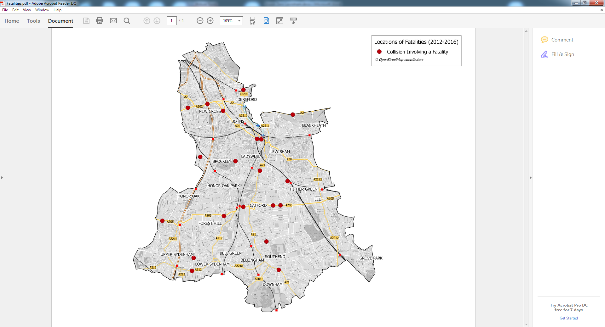

# Where casualties occurred

The majority of casualties occurred on the major routes with 67% (3,354 out of 5,040) occurring on A classified roads.

The majority of casualties also occurred at junctions – particularly priority “give way” junctions. Vulnerable road users are particularly exposed at such locations and Section 5 of this note highlighted the prevalence of risk associated with turning vehicles (particularly for cyclists and P2Ws).

Queuing, congested traffic on busy roads can lead to specific behaviours that increase casualty risk such as filtering, crossing between queues and undertaking etc – exacerbated by differentials in speeds (e.g. queuing/stationary traffic lanes alongside free flowing areas such as bus lanes). These are conditions most likely to occur on major roads.

Table 7.1 – Casualties by junction type on LBL roads (2012-2016)



Table 7.2 – Casualties by junction control on LBL roads (2012-2016)



The heat maps below also illustrate the issues on the major road network with particularly high casualty densities on the A21, A20, A2 and Lower Sydenham Gyratory. This reiterates the huge challenge of accommodating active (but vulnerable) modes in heavily trafficked areas within London.

Some concentrations of casualties occurred near the public transport facilities of New Cross/New Cross Gate Stations, Brockley Station, Forest Hill Station (A205), Bellingham Station and Grove Park Station. Providing safe interchange will be an important factor in delivering Healthy Streets and an environment to encourage active travel in the borough.

Pedestrian casualties were particularly concentrated around areas of high activity such as the busy ‘town centre’ areas of Catford, Lewisham and New Cross and some of the transport interchanges noted above.

A high concentration of pedal cycle casualties occurred on the A200 (near to Deptford Park) and in the area around Forest Hill Station (A205).

Figure 7.1 – Casualty heat map (Total Casualties: 2012-2016)

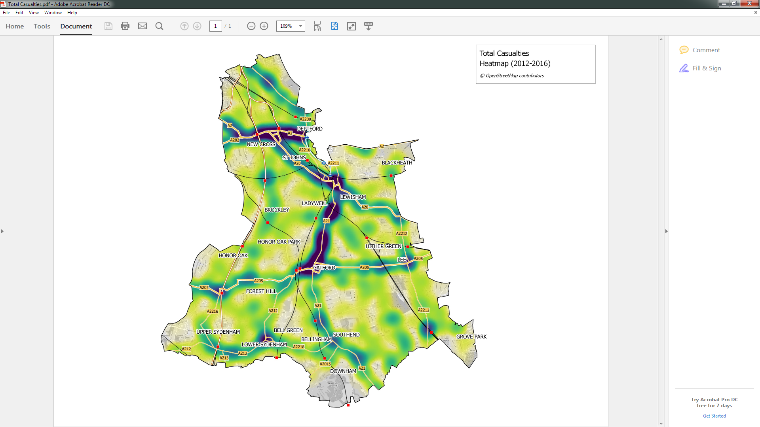

Figure 7.2 – Casualty heat map (Pedestrian Casualties: 2012-2016)

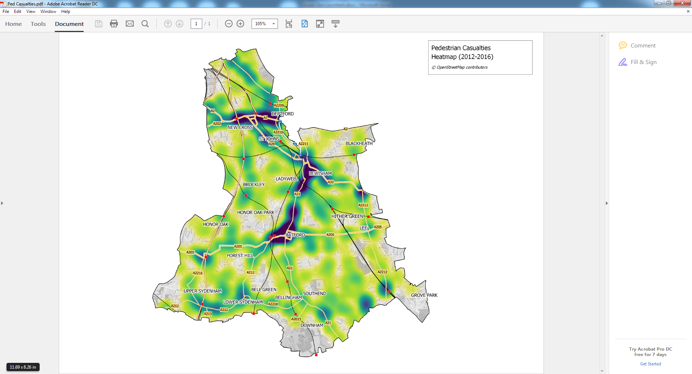

Figure 7.3 – Casualty heat map (Cycle Casualties: 2012-2016)

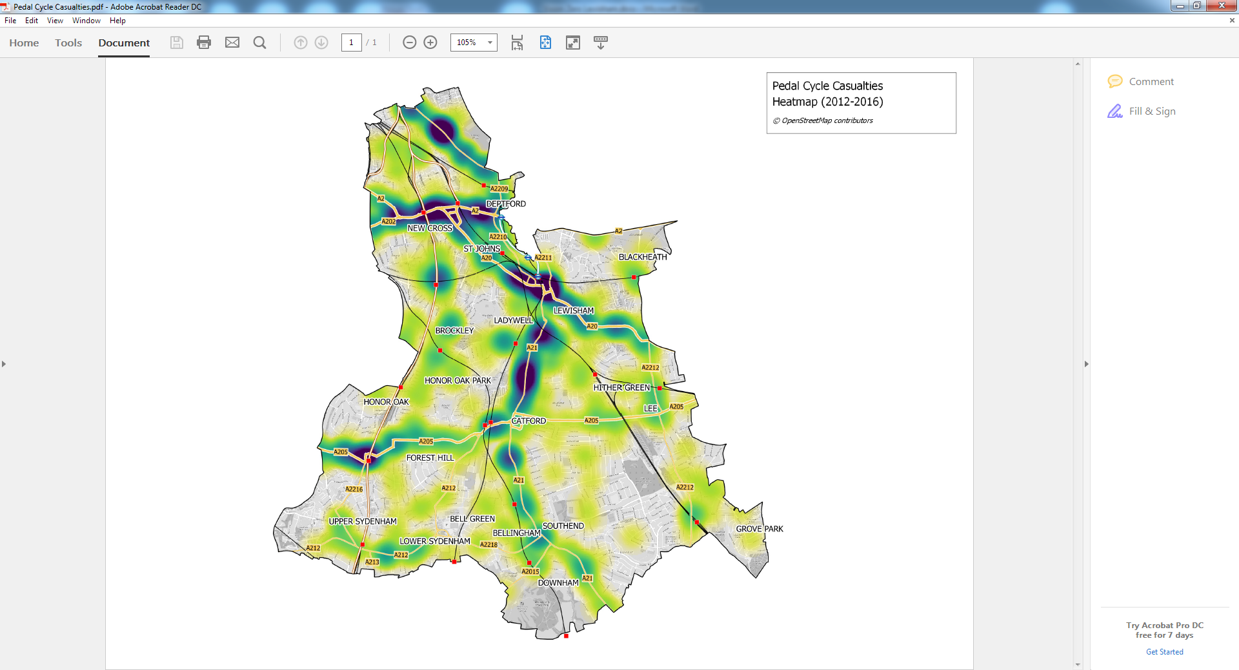

Figure 7.4 – Casualty heat map (P2W Casualties: 2012-2016)

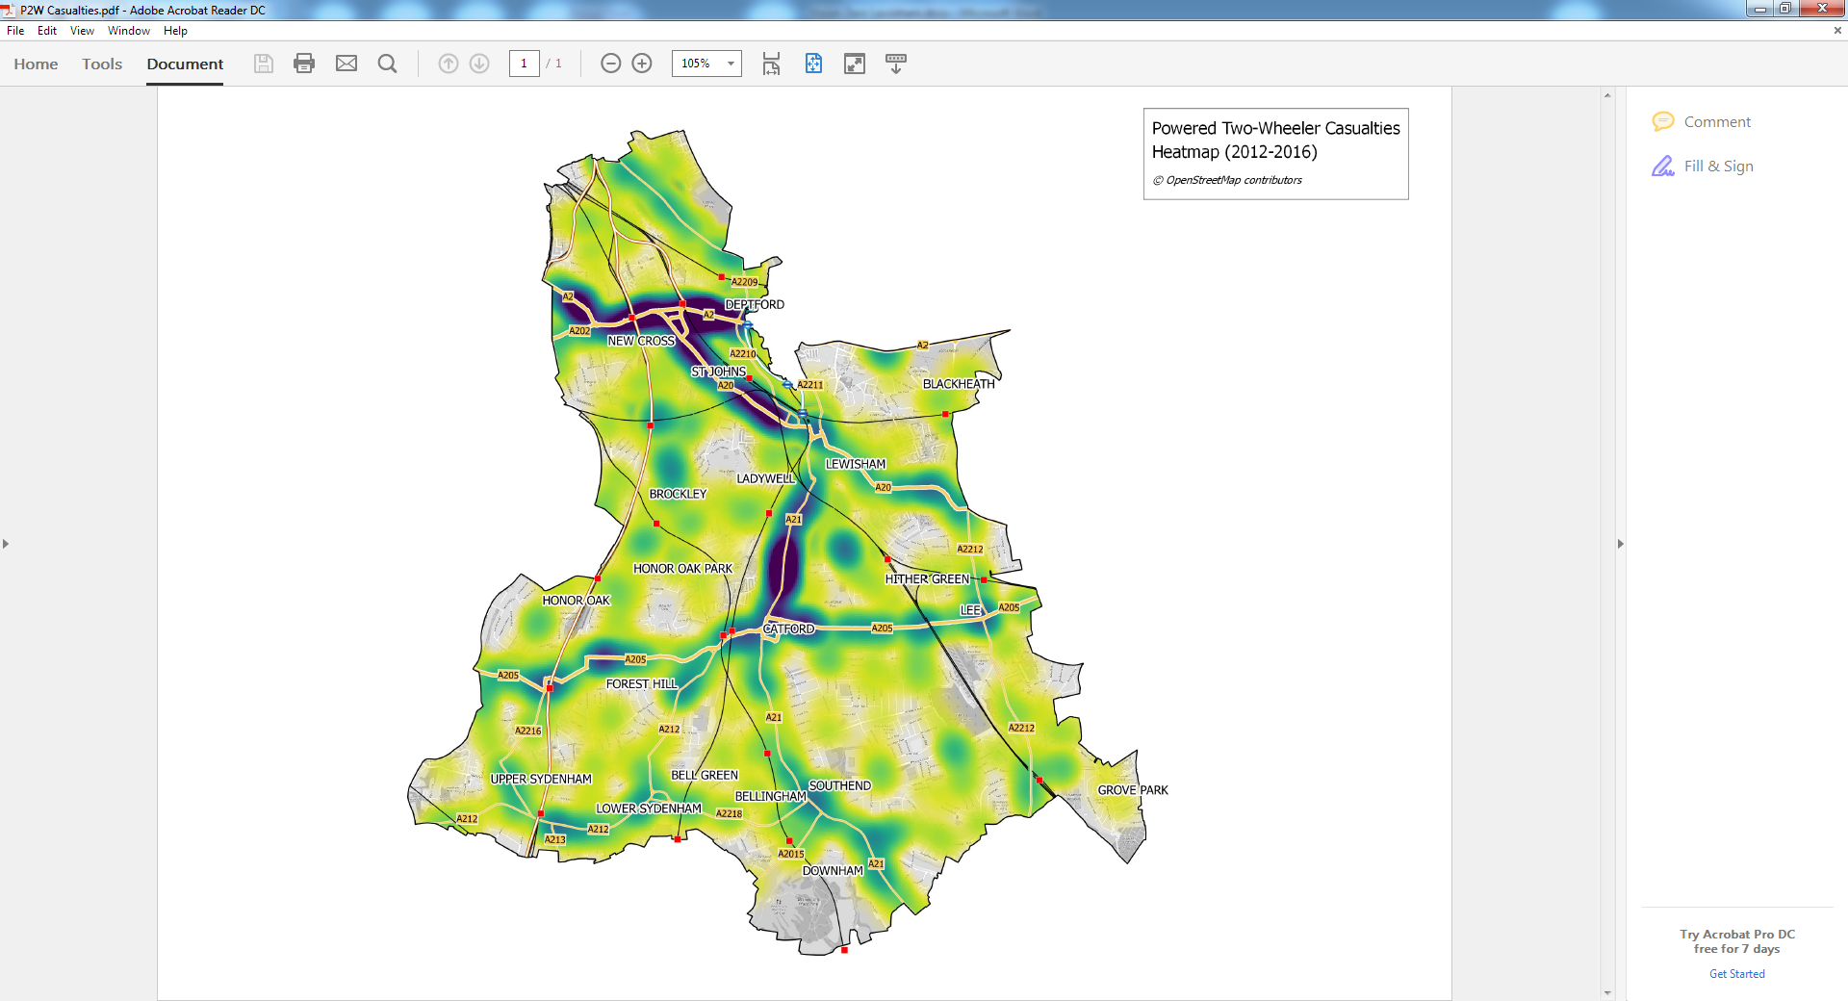

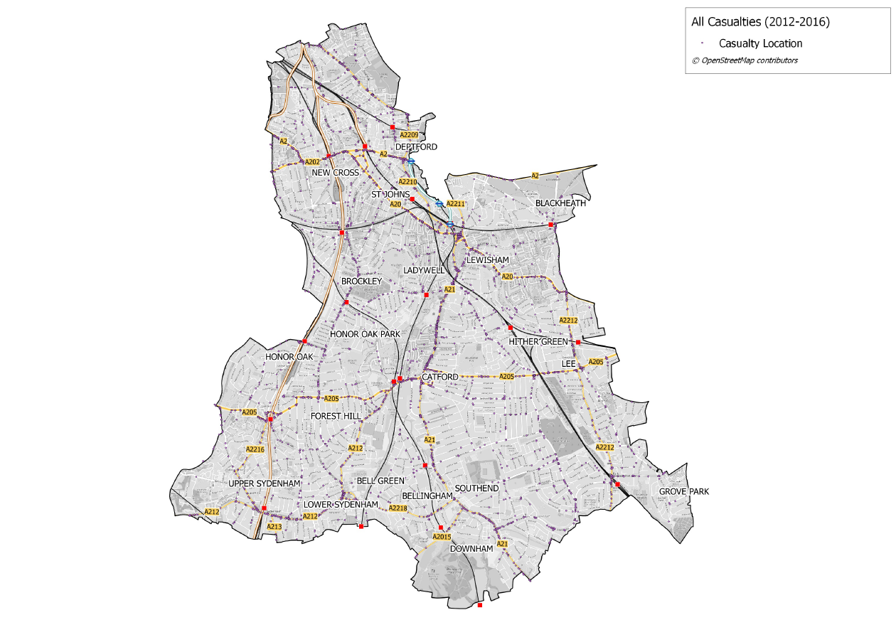

# Casualty Analysis Summary

A summary of the main finding from the casualty analysis is provided below:

* A total of 5,040 casualties were recorded in LBL between 2012 and 2016. This included 329 serious casualties and 20 fatalities.
* There has been a significant drop in KSI casualties since 2013 – this is a pattern in evidence throughout Inner London. However, LBL will need to reduce KSI casualties by a further 23 (compared to 2016 levels) in order to meet the ‘Vision Zero’ targets for 2022.
* There is evidence of a slight rising trend in the number of casualties was observed although this is not considered a significant trend with casualties tending to fluctuate.
* A general increase in the number of P2W casualties has been and this will be a key focus in LBL delivering Vision Zero targets
* The number of cycle casualties was found to be significantly below (Chi-squared) the levels expected compared to the rest of Inner London. However, prevailing levels of cycling (lower than some Inner London areas) in LBL was likely a key factor in this. As cycling levels, careful attention will be required to minimise cycle casualties.
* Overall, there has been a decline in KSI casualties with levels significantly dropping since 2013 (no clear attributable reason as to why). This was a part of a wider Inner London trend.
* An approach to the data described in this note (RI) suggested cycle casualties to be most out of line with expected levels based on assumed exposure/estimated modal split. P2Ws were also found to be ‘at risk’
* The RI approach indicated males, age 16-24, to be the most ‘at risk’ category compared to the relative proportions of these groups in London population estimates – this was particularly apparent with P2W casualties
* The number of P2Ws involved in pedestrian casualties appeared much higher than expected based on average levels of P2W use
* Goods vehicle involvement in all vulnerable road user casualties was high when compared to the expected volume of goods vehicles on the network
* At total of 20 fatalities were recorded during 2012-2016. 60% involved a pedestrian, 15% involved a P2W and 10% involved a cyclist
* 35% of all fatalities recorded involved a heavy goods vehicle
* The majority of casualties occurred at junctions – particularly priority giveway junctions
* The majority of casualties occurred on the major A road network
* Heat maps produced indicate the main concentration of casualties are on the major routes of the A21, A20 and A2, which are all managed by Transport for London.
* The highest density of pedestrian casualties occurred in areas of high activity – close to transport interchanges or the high street areas of Lewisham, Catford and New Cross
* Other than the main routes noted above, there were other notable concentrations of cycle casualties on the A200 (Deptford Park) and around Forest Hill Station (A205).

# Achieving Vision Zero

Lewisham supports the Mayors ambition for Vision Zero and welcomes the publication of the Vision Zero action plan.

In order to achieve the ambitious targets of Vision Zero, the Council have adopted the approach outlined in the Mayor’s Vision Zero Action Plan (July 2018). This centres around five pillars of action which will be used to guide schemes and interventions to achieve a more holistic approach that more effectively aligns with the challenges in achieving Vision Zero.

## Lewisham’s 5 Pillars of Action

Good progress has been made over recent years towards our own ambitious road safety targets taking the industry recognised approach, including the adoption of 20mph speed limits that were introduced on all Borough-controlled roads in September 2016, improvements to cycle routes, enhanced crossing facilities and an ongoing Road Safety Education programme.

However, the Council appreciates that in order to eliminate death and serious injury from Lewisham’s roads, a new approach should be considered.

The Lewisham LIP3 delivery plan takes on board much of the new concepts around road danger reduction in its programmes. Measures that have been outlined in the LIP that align with the five pillars of action are summarised below. Further detail on this will be added over the coming months, for inclusion with the final LIP3 document.

## Safe Speeds

* Road danger reduction programme focussing on 20mph compliance
* New use of Commonplace data to identify areas of perceived danger
* Work with TfL to reduce speed limits on TLRN

## Safe Streets

* Introduction of a new healthy neighbourhood programme
* Implementation of Deptford Park liveable neighbourhood
* Local cycling and pedestrian improvements programme

## Safe Vehicles

* Introduction of new public transport supporting interventions programme
* Review of Council fleet and contracts
* Investigation into freight and construction consolidation in borough growth areas

## Safe Behaviours

* Newly refined smarter and safer travel programme
* Continuation of evidence based traffic enforcement
* Maintenance of high STARS accreditation across borough

## Post-collision response

* Continued close liaison with police following KSI collisions
* Lobby authorities for timely and accurate collision data and analysis

1. Note: Regression prediction intervals become wider as variability in the source data increases. Prediction intervals also become wider the further into the future predictions are made, indicating a reduced confidence as distance from the observed data increases. Rolling averages smooth the data and produce tighter prediction intervals.