Private Rented Sector Licensing in Lewisham
Evidence for consultation 2022

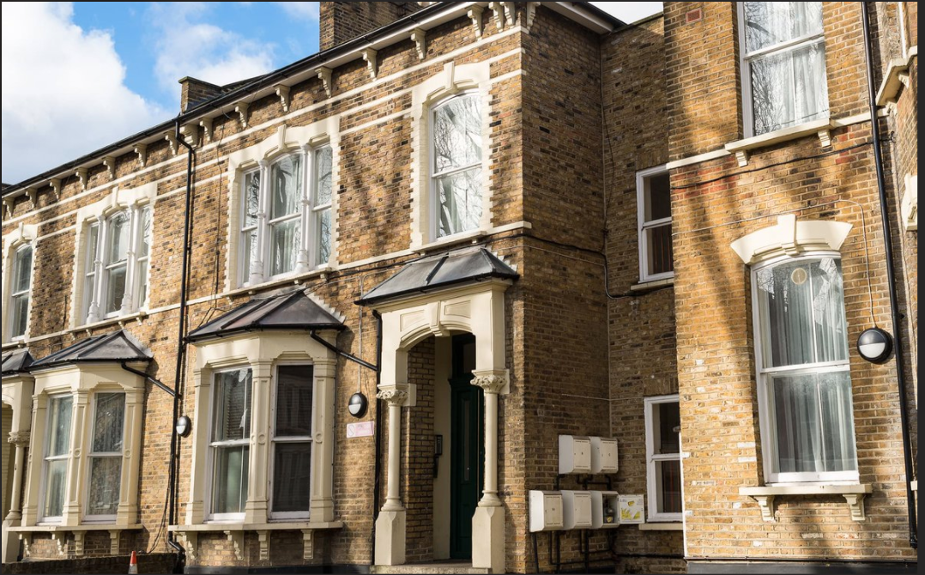

Contents
Glossary 3
Executive Summary 4
The private rented sector in Lewisham 5
Property licensing schemes 6
Licensing schemes in Lewisham 6
Proposed licensing Schemes for Lewisham 7
Designation 1: ASB and poor property conditions 11
Designation 2: Poor Housing Conditions 14
Designation 3: Deprivation 17
Proposed licence fee 19
Proposed Scheme objectives 20
Alternative options considered 24

Glossary
Term | Meaning
Socially rented | Homes rented from the council or a housing association
Privately rented | Homes rented from a private landlord
Private rented sector (PRS) | The portion of housing in the borough that is rented from private landlords
Category 1 hazard (Cat 1 hazard) | A serious or immediate risk to a person's health and safety that is related to housing
Category 2 hazard | A less serious or less urgent risk that can still be regarded as placing the occupiers’ health, safety and welfare at risk
Housing Health and Safety Rating System (HHSRS) | A government prescribed system that rates housing hazards based on their risk to occupiers’ health, safety and welfare
Designation | A geographical area chosen for licensing based on evidence
Deprivation | Living on low income and not having the money to pay for some basic requirements.
Indices of Multiple Deprivation | A dataset produced by the government to give a relative value to how deprived an area is, compared to the rest of the country.
Barriers to housing and services | One of the government’s measures of deprivation. It combines measures relating to housing affordability, overcrowding and homelessness.
Anti-social behaviour (ASB) | Behaviour related to a rented property that causes annoyance and irritation to neighbours and the community. Most commonly noise, litter and waste.
Selective Licensing | A local scheme which requires landlords to have a licence to legally let their property to a family or two sharers
Additional HMO Licensing | A local scheme which requires landlords to have a licence to legally let their property to three or four sharers
Mandatory HMO Licensing | A national scheme which requires landlords to have a licence to legally let their property to five or more unrelated sharers.

Executive Summary
The council is committed to supporting Lewisham’s citizens in accessing and living in good quality housing that improves their opportunities for employment, education, health and wellbeing. We recognise that suitable housing is central to creating dynamic and prosperous communities that are well-connected to the opportunities that London offers. The quality of housing in the private rented sector is of particular concern and the council will not turn a blind eye to conditions that put the safety of residents at risk.
In 2018, the council looked at the possibility of introducing a borough-wide selective scheme. The information gathered at the time showed a clear link between private rented properties, antisocial behaviour, crime and deprivation. This evidence was used in the public consultation conducted in the summer of 2019.
In March 2020 the Mayor and cabinet approved the submission of an application to the Secretary of State, Department for Levelling Up, Housing and Communities, for borough wide selective licensing. However, the process of moving forward to making that application was halted by the Covid-19 pandemic. Post lockdown, the council reviewed housing conditions in the borough, and this has led to a fundamental rethink on how best to operate Selective Licencing in Lewisham. Therefore, a new public consultation is required
The council is proposing a five-year selective licensing scheme made up of three areas or designations. Due to the size of the scheme, after being agreed by the London Borough of Lewisham, these designations would need confirmation by the Secretary of State at the Department for Levelling Up, Housing and Communities (DLUHC). If approved, these could be introduced in 2023.
The wards of Telegraph Hill and Blackheath are not included in any of the designations as there was not sufficient evidence. However, with the rapid growth of PRS in Lewisham, the service will continue to monitor the ASB and property conditions in these wards and if required, apply for selective licensing at the appropriate time.
Your thoughts and views are welcome on the proposed selective licensing scheme and any representations and suggestions will be carefully considered when coming to a final decision on the scheme.

The private rented sector in Lewisham
Population growth, a limited supply of new homes and a huge increase in house prices has caused profound shifts in the private rented sector. There has been a 38% increase in the number of households living in private rented properties over the last ten years, including a growing number of families with children. Lewisham’s PRS is now calculated to make up 31% of housing stock.This compares to 24.3% of households in 2011 (ONS). There are a total of 128,798 residential dwellings in Lewisham, an estimated 39,674 of which are now privately rented.

Figure 1 Tenure profile from 2001 to 2021 (Source: ONS & Metastreet)

The increase in the private rented sector in Lewisham over the last two decades has been consistent with the wider London trend. Private renting has grown at the expense of owner occupation and social housing. However, a sizable proportion of the growth appears to come from new supply.
One of the major changes to the PRS across London over the last 20 years has been the increase in rent. This has resulted in problems with residents being able to afford and access decent, affordable housing. This trend has resulted in many households being forced to put up with sub-standard properties, with a range of housing hazards.
Housing hazards are rated by severity. A category 1 hazard is a serious or immediate risk to a person's health and safety. A significant category 2 hazard, although less serious or less urgent, can still be regarded as placing the occupiers’ health, safety and welfare at risk. These are defined in the Housing Health and Safety Rating System (HHSRS).
In 2020, 13% of private rented dwellings in England had at least one Category 1 hazard. The PRS in Lewisham has 22.7% of properties with at least one category 1 hazard; much higher than the national average.
Housing conditions are affected by the level of maintenance and quality of repair, thermal efficiency, type of construction and the age of the property. There is a gradient of risk with the age of the property, the risk being greatest in dwellings built before 1900, and lowest in the more energy efficient dwellings built after 1980. Lewisham has a significant number of residential properties (53.4%) built pre-Second World War. Wards with a majority of older properties tend to have more hazards such as excess cold, fire & electrical issues, damp and mould.

Property licensing schemes
Property licensing allows the council to improve the condition and management of privately rented properties. This helps to make renting in the private rented sector safer and fairer for tenants.
There will potentially be three types of property licensing schemes operating in Lewisham:

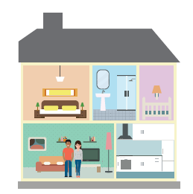
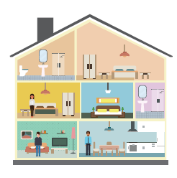
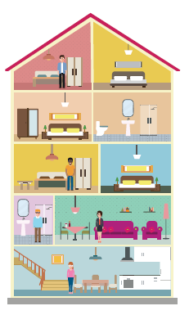

- Applies to properties let to single family household or two sharers
- Area designated by the council
- Large schemes need approval by the Secretary of State
- Applies to houses and flats in multiple occupation (HMOs) let to 3 or 4 unrelated people, forming 2 or more households who share amenities such as a kitchen or bathroom.
- Area designated by the council
- Applies to large HMOs, let to 5 or more unrelated people, forming 2 or more households who share amenities such as a kitchen or bathroom.
- National scheme
Selective Licensing
Additional HMO Licensing
Mandatory HMO Licensing

Licensing schemes in Lewisham
Licensing schemes require landlords letting privately rented properties in the designated areas to hold a licence and comply with the licence conditions. The council has worked collaboratively with landlords to make sure these requirements are met. The council has carried out enforcement actions when needed to raise standards.
The London Borough of Lewisham has not previously adopted selective licensing.
An Additional Licensing scheme started in February 2017 and continues for five years until 10 February 2022. A new Additional Scheme will come into force on Tuesday 5 April 2022 and will apply to any HMO property in Lewisham that is not captured by the national Mandatory Scheme or is specifically excluded from Licensing.
The national Mandatory HMO licensing scheme came into operation since April 2006 when the council was required to run it by law.
Whilst the HMO schemes have enabled the council to begin to make real progress in raising standards in the private rented sector, there is still much more to do. The data shows that issues exist across the private rented sector. For example, properties converted into studios share many of the same issues associated with HMOs, such as ASB, Waste Management, etc.
Listed below are several examples of landlord behaviour and issues that have been reported to Lewisham Council. These highlight the need for the PRS to be regulated through licensing.
  - A landlord forced tenants to move out of their studio for 13 days in order to pass an inspection, which would have made the property look like a one-bedroom flat, rather than two studios. The tenants received no compensation for this inconvenience.
  - A landlord ignored complaints from the tenants about antisocial behaviour for over two years.
  - The tenant complained to their landlord about a leak in the ceiling and was threatened with violence.
  - The landlord had allowed the property to fall into disrepair and wanted the tenant to leave. She had no running water in the property, which she shared with her eleven-year-old daughter.
  - The tenant called the landlord to ask them to change the time at which thermostat came on. The tenant was told that she was causing a disturbance. She was asked to leave the property within six days, when the tenancy agreement stated it had to be 30 days. The police found this to be a criminal eviction.
  - The tenant moved into a property that was damp on the day they moved in caused by water leaking through the ceiling.

Proposed licensing Schemes for Lewisham
Lewisham Council has been truly selective in proposing the areas for this licensing scheme. Thorough evidence gathering has been carried out to ensure that the most severe problems in each ward can be dealt with appropriately through licensing. The council proposes to introduce selective licensing in three areas or designations. The justification for dividing the wards in this way is due to the varying levels of ASB, poor housing conditions and deprivation in the areas. Due to the size of the proposed designation, if the scheme is agreed by Lewisham Council’s Mayor and Cabinet Committee, it will need confirmation by the Secretary of State at the Department of Levelling Up, Housing and Communities (DLUHC).
All properties in the designated areas that are rented to single families (or two sharers) will need to have a licence to be legally let.
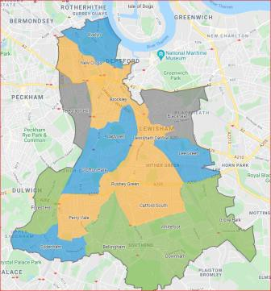
Designation 1 | Designation 2 | Designation 3
High Repeat ASB and Poor Housing Conditions | Poor Housing Conditions | Deprivation
Rushey Green, Brockley, New Cross, Catford South, Lewisham Central and Perry Vale | Evelyn, Ladywell,  Lee Green, Crofton Park and Sydenham. | Downham, Bellingham, Whitefoot, Forest Hill and Grove Park.

6.1 High levels of PRS
In order for a selective licensing scheme to be considered, the area must contain a high proportion of properties in the private rented sector. The PRS in Lewisham is distributed across all 18 wards. The number of PRS dwellings per ward ranges from 4,398 (Lewisham Central) to 1,492 (Downham). The percentage of PRS properties in each ward ranges from between 41.1% (Lewisham Central) to 23.8% (Downham) (Figure 2). Therefore, all of Lewisham’s wards have a higher percentage PRS than the national average of 19%..

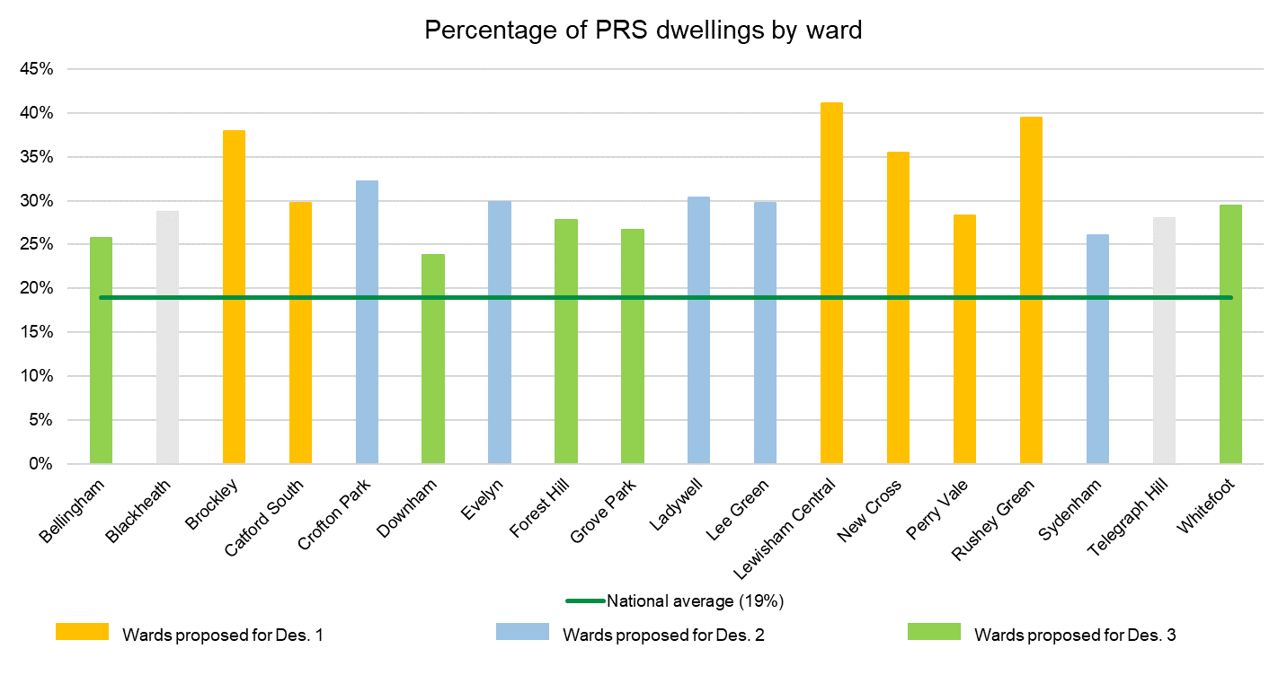
Figure 2 Percentage of PRS dwellings by each ward (Source Ti 2021).
All schemes have a set of conditions attached to the issuing of the licence. The licence conditions deal with issues such as repairs, permitted occupancy and other issues that affect the health and welfare of tenants. There are different conditions attached to each designated area.This is to ensure that specific issues such as cold, damp, ASB, energy efficiency and fuel poverty are dealt with accordingly. The three areas have been designated based on the following data displayed in the table below.

6.2 High levels of poor property conditions
There are 8,995 private rented properties in Lewisham that are likely to have at least 1 serious housing hazard (Category 1, HHSRS). This represents 22.7% of the PRS stock. PRS properties with serious hazards are distributed across the borough.
Ward | Dwellings |  |  | Poor Property Conditions (PPC) Indicators |  |  |  | High Repeat ASB Indicator |  |  | Deprivation (Dep) Indicator |  | Designation
 | Total dwellings | PRS¹ | % PRS (minus known HMOs) ² | PRS with at least 1 Cat 1 hazard ³ | PRS dwellings with at least 1 Cat 1 (%) ⁴ | PRS complaints recorded | PRS notices served | ASB incidents (2016-21) | No. PRS with repeat ASB | No. repeat ASB incidents⁵ | Tenancy Deposit Scheme Register | HB claims 2016-21
Brockley | 8059 | 3056 | 37.90% | 488 | 16 | 177 | 50 | 444 | 67 | 250 | 1756 | 1150 | 1
Lewisham Central | 10688 | 4398 | 41.10% | 717 | 16.3 | 267 | 100 | 483 | 85 | 222 | 2018 | 2286 | 1
Rushey Green | 7271 | 2863 | 39.40% | 736 | 25.7 | 261 | 81 | 513 | 95 | 242 | 983 | 2827 | 1
New Cross | 8176 | 2905 | 35.50% | 515 | 17.7 | 204 | 90 | 352 | 55 | 153 | 7232 | 1623 | 1
Catford South | 5872 | 1744 | 29.70% | 611 | 35 | 174 | 57 | 451 | 80 | 231 | 674 | 1280 | 1
Perry Vale | 6849 | 1936 | 28.30% | 462 | 23.9 | 121 | 18 | 354 | 66 | 200 | 770 | 1004 | 1
Evelyn | 9273 | 2761 | 29.80% | 390 | 14.1 | 167 | 94 | 283 | 33 | 85 | 1067 | 1228 | 2
Ladywell | 5796 | 1761 | 30.40% | 459 | 26.1 | 116 | 39 | 318 | 50 | 154 | 1644 | 882 | 2
Lee Green | 6296 | 1868 | 29.70% | 457 | 24.5 | 104 | 36 | 278 | 45 | 120 | 1175 | 873 | 2
Sydenham | 7099 | 1851 | 26.10% | 771 | 41.7 | 126 | 59 | 263 | 46 | 125 | 656 | 1218 | 2
Crofton Park | 6356 | 2049 | 32.20% | 493 | 24.1 | 178 | 51 | 322 | 49 | 127 | 2285 | 1105 | 2
Bellingham | 6656 | 1717 | 25.80% | 424 | 24.7 | 120 | 16 | 343 | 66 | 170 | 922 | 2082 | 3
Downham | 6271 | 1492 | 23.80% | 404 | 27.1 | 97 | 35 | 309 | 49 | 122 | 1613 | 1256 | 3
Forest Hill | 6834 | 1899 | 27.80% | 394 | 20.7 | 64 | 11 | 217 | 34 | 88 | 808 | 690 | 3
Grove Park | 6368 | 1702 | 26.70% | 407 | 23.9 | 88 | 14 | 292 | 43 | 114 | 3104 | 1156 | 3
Whitefoot | 6009 | 1769 | 29.40% | 482 | 27.2 | 120 | 25 | 315 | 45 | 116 | 1126 | 2168 | 3
Telegraph Hill | 6816 | 1907 | 28.00% | 419 | 22 | 141 | 42 | 224 | 32 | 90 | 7690 | 1005
Blackheath | 6944 | 1996 | 28.70% | 366 | 18.3 | 77 | 39 | 187 | 32 | 86 | 2203 | 489
Grand Total | 128065 | 39674 | 30.98% | 8995 | 22.7 | 2602 | 857 | 5948 | 972 | 2695 | 37726 | 24322
Table 1 Summary of Data by Ward
Designation 1: ASB and poor property conditions
Wards included - Brockley, Catford South, Lewisham Central, New Cross, Rushey Green and Perry Vale.

7.1 Evidence of significant and persistent ASB
Significant and persistent ASB occurring within the property or its immediate vicinity is the main criteria for this designation. This includes intimidation or harassment, noise, rowdy and nuisance behaviour, animal and vehicle-related nuisance, antisocial drinking, drugtaking or dealing, graffiti and fly posting, and litter and waste.
These wards have the highest levels of ASB connected to the PRS compared to the other wards in the borough. The wards have high and repeat ASB due to the evidence of;
  - PRS properties with a high number of recorded incidents of ASB linked to them, and, (Fig 3)
  - a very high number of ASB incidents linked to the same properties (Fig 4).

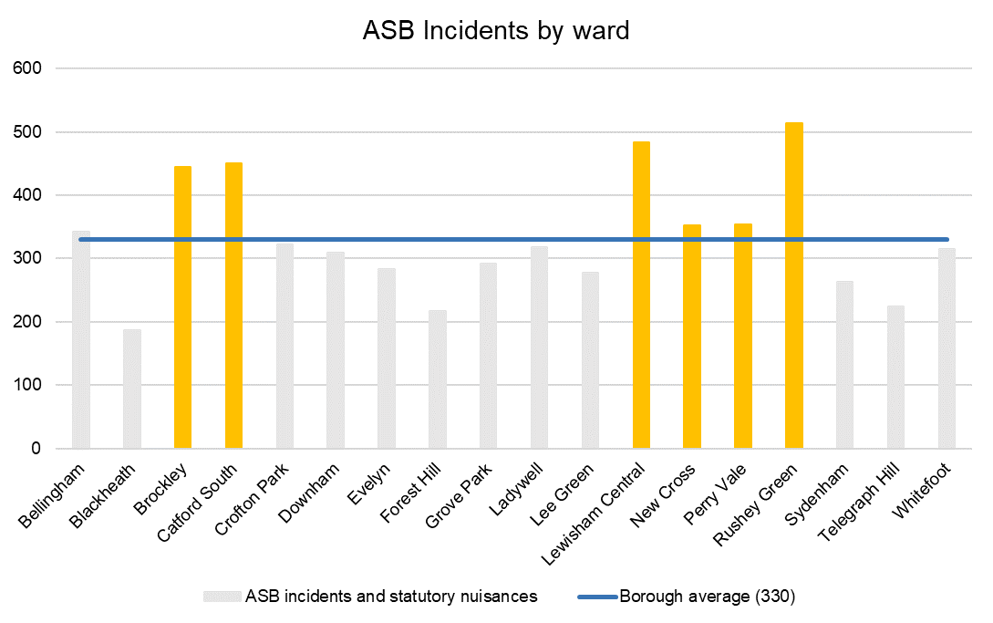
Figure 3 ASB incidents by ward (2016 – 2021)

Ward | PRS properties with repeat ASB
Bellingham | 66
Blackheath | 32
Brockley | 67
Catford South | 80
Crofton Park | 49
Downham | 49
Evelyn | 33
Forest Hill | 34
Grove Park | 43
Ladywell | 50
Lee Green | 45
Lewisham Central | 85
New Cross | 55
Perry Vale | 66
Rushey Green | 95
Sydenham | 46
Telegraph Hill | 32
Whitefoot | 45
Borough average | 54
Figure 4 Number of PRS with repeat ASB, by ward

7.2 ASB by tenure
This graph show that there is evidence of increased ASB in the wards in the designation, and that there is more ASB in the PRS than in either social rented or owner-occupied properties. The table also shows that the repeat ASB in these wards is worse than the borough average.
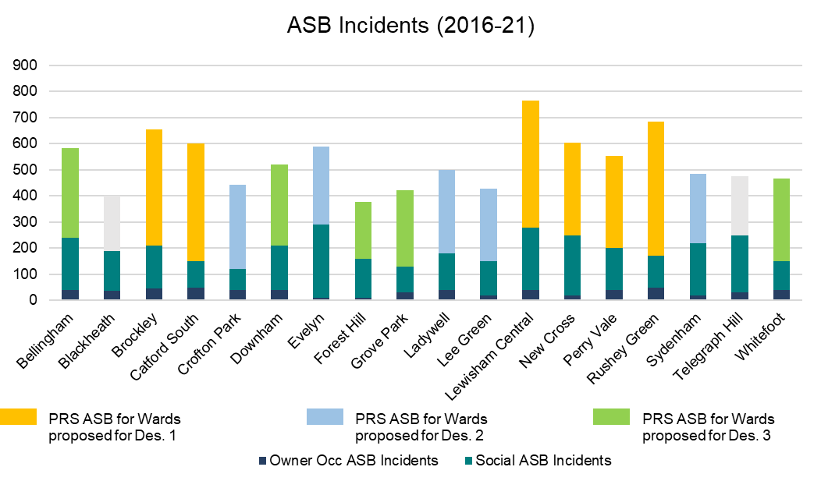
Figure 5 ASB Incidents by tenure type by ward (Source: Ti 2021).

7.3 Poor property conditions
The Housing Stock and Stressors Report assessed properties in the private rented sector that are likely to need an inspection to determine whether any of those properties contain Category 1 hazards. This also takes into account properties where the council has received complaints about the PRS.
The wards in the designation showed significant indicators of poor property conditions. This means that the wards in this designation are likely to have poor property conditions that are much worse than the national average. (See Figure 5 under Designation 2).

7.4 How will selective licensing deal with ASB in the designated area?
A designation of these six wards would allow the council to work proactively with the landlords and owners of the properties to prevent ASB and, where necessary, deal with ASB in their properties. The licence conditions will clearly state the responsibilities of landlords to prevent and deal with any ASB that arises. The council will provide guidance and support for landlords on how to manage tenants who are causing ASB. Information for tenants about their responsibilities about causing ASB will also be available.
A selective licensing scheme in these wards would give the council greater intelligence about the PRS and powers to deal with the property issues that cause problems for neighbours and the community.

7.5 The proposed selective licence conditions for designation 1
As designation 1 is based on ASB there are specific, licence conditions relating to ASB that we propose to enforce in addition to the standard set of licence conditions. These are:
- To empower landlords to take up references before renting, issue an ASB policy as part of the tenant information pack (a model policy is available to the landlord on Lewisham’s website). The licence holder will be asked to demonstrate what measures they have taken to address ASB in/around their property within 7 days of the request.
- To make failing to effectively manage ASB in their properties, they would be in breach of licence conditions for which they can be either fined or prosecuted. Serious or repeated breaches of licencing conditions could result in the licence being revoked. Multiple civil penalty notices (CPNs) or a conviction will make the licence holder no longer fit and proper to hold a licence to rent in England and Wales.
- All repair work must be carried out within a reasonable timescale with due regard to the severity of the issue.
- The Licence holder must ensure that any repairs, improvement works or treatments are carried out by a competent person(s). Copies of receipts and/or invoices for any such works must be provided to the Authority within 28 days upon demand.

Designation 2: Poor Housing Conditions
Wards included - Evelyn, Ladywell, Lee Green, Crofton Park and Sydenham.

8.1 Evidence of poor property conditions
A study was carried out to predict the number of PRS properties in the borough and whether these properties are likely to contain any category 1 hazards. Using a sample of properties that are known to have at least one serious housing hazard (Category 1, HHSRS), it is possible to predict the number of PRS properties with at least one serious hazard across the borough.

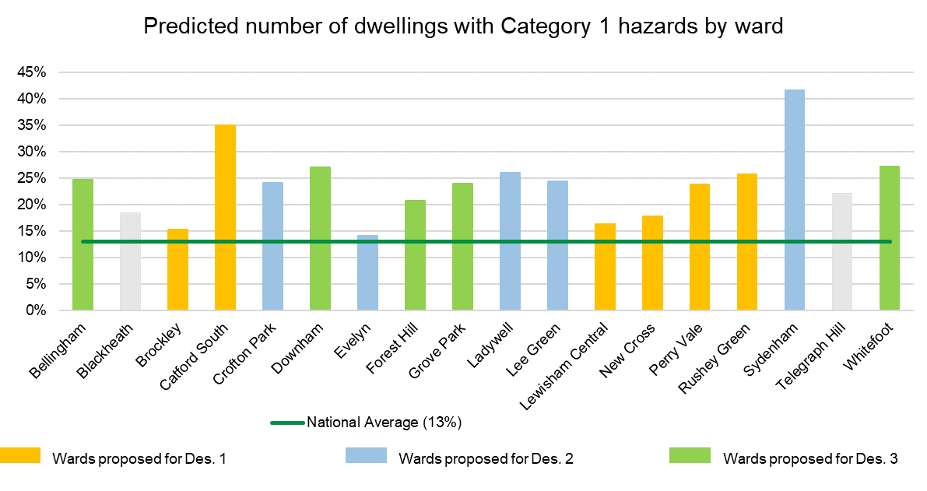
Figure 6 Predicted number of dwellings with Category 1 hazards by ward (Source: Ti 2021).

All of the wards in the borough are predicted to have more cat 1 hazards in the PRS than the national average of 13%. The five wards in designation 2 have a level of PRS properties with cat 1 hazards that is higher than the national average. Sydenham in particular has very high levels of precited cat 1 hazards.
Whilst there are some other wards that have high levels of cat 1 hazards, Catford South and Downham, for example, these are included in the other designations under a main criterion which requires other interventions.
Complaints made by PRS tenants and investigated by Lewisham Council regarding poor property conditions and inadequate property management are a direct indicator of low quality PRS. Lewisham recorded 2,602 complaints from private tenants over a 5-year period (Figure 7).
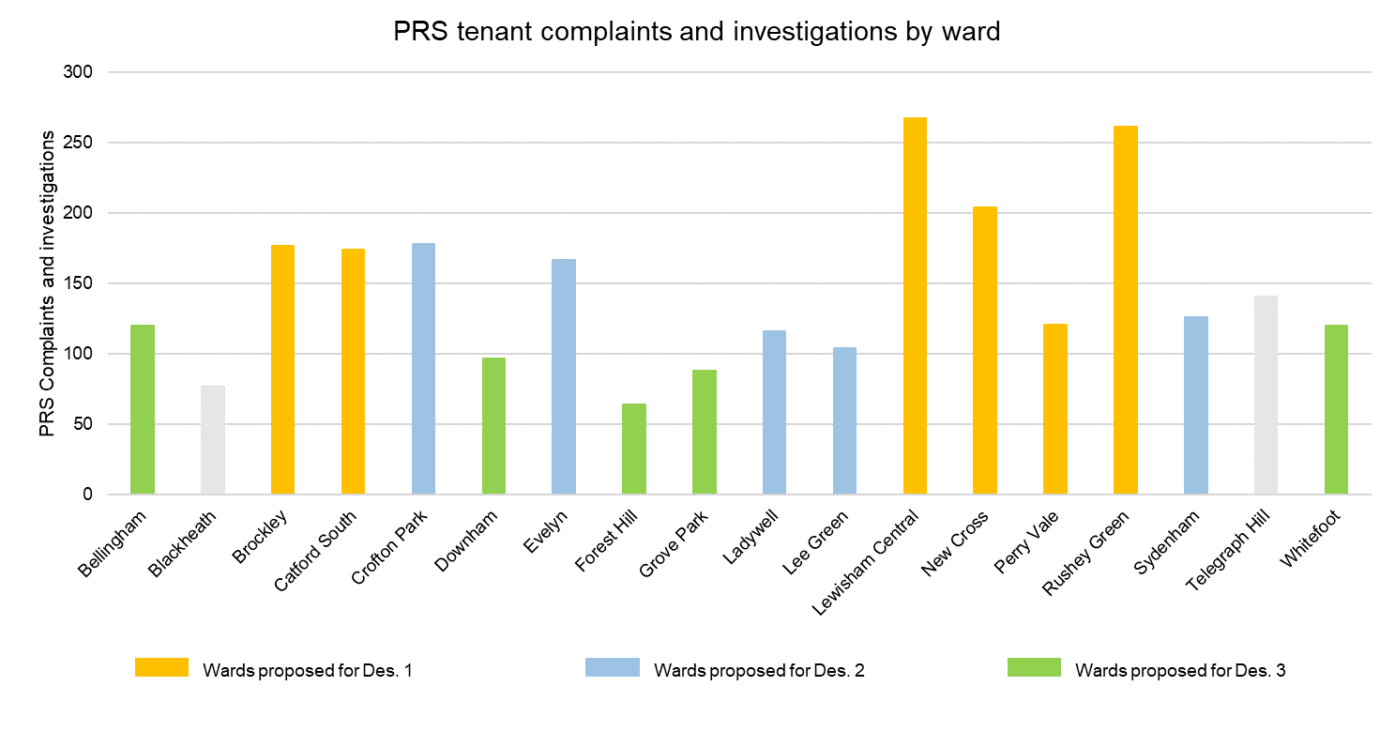
Figure 7 . PRS tenant complaints and investigations (Source Ti 2021)

8.2 How will licensing deal with poor property conditions in the designated area?
There will be clear licence conditions relating to the standard and management of rented properties in the area. Higher risk properties will be prioritised for inspection by officers to check for hazards and compliance with licence conditions. The council will take enforcement action (under Part 1 of the Housing Act or against breaches of licence conditions), where necessary, to improve poor property conditions.
It is much easier to rectify property issues under the legal framework of the licensing scheme and when the landlord and other property management companies are known to the council. The licence conditions will be used to ensure continued compliance with property conditions and standards to prevent a further deterioration in the rented properties. Landlords who fail to license their properties or maintain their properties to a licensable standard could receive a civil penalty or be prosecuted.
Information and support on the professional management of properties will be available to landlords through the council’s website. The licence conditions relating to the management of the properties will help ensure that properties are properly managed to prevent further deterioration.
The outcome of the designation should be (together with other measures) a reduction of the problems with housing in the private rented sector contributing to the high level of deprivation.

8.3 Proposed Selective Licensing Conditions for Designation 2
As designation 2 is based on poor property conditions there are specific licence conditions that we propose to enforce in addition to the standard set of licence conditions. These are:
- All repair work must be carried out within a reasonable timescale with due regard to the severity of the issue.
- The Licence Holder must ensure that any repairs, improvement works or treatments are carried out by a competent person(s). Copies of receipts and/or invoices for any such works must be provided to the Authority within 28 days upon demand.
For a full breakdown see - Selective Licence Conditions)
Designation 3: Deprivation
Wards included - Bellingham, Downham, Forest Hill, Grove Park and Whitefoot.

9.1 Evidence of deprivation
These five wards are all in the bottom 50% of deprived wards in the country. The government uses a range of measures to produce Indices of Multiple Deprivation. This allows areas to be ranked nationally between 0.1 as the most deprived and 10.0 as the least deprived. These five wards sit between 2.3 and 5.0 and are some of the most deprived in the borough. The council knows that poor property conditions make deprivation worse. People living in deprived areas have fewer choices about where they can live and are often stuck in overcrowded, poorly maintained accommodation.

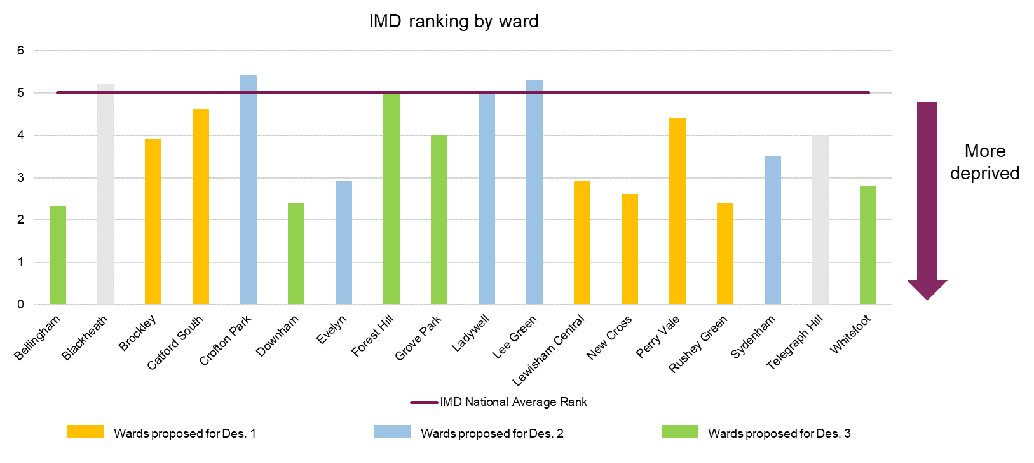
Figure 8 Indices of Multiple Deprivation (Source: Ti 2021).

An additional measure that inputs to the Indices of Multiple Deprivation is based on barriers to housing and services. In Lewisham, all wards are in the bottom 50 percentile of wards in England for this measure, with the wards in this designation performing particularly badly.
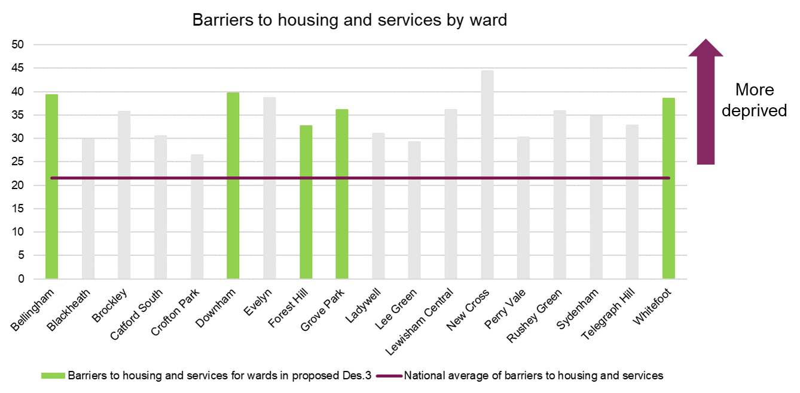
Figure 9 Barriers to Housing and Services (Source: Ti 2021).
The legislation suggest that the following factors may be considered when assessing whether an area is suffering from high levels of deprivation; the employment status of adults; the average income of households; the health of households; the availability and ease of access to education, training and other services for households; housing conditions; the physical environment; levels of crime and average income of households.
The following housing benefit data is an indication of the low average income of households in the designation.

Ward | HB claims  2016-21
Bellingham | 2,082
Downham | 1256
Forest Hill | 690
Grove Park | 1,156
Whitefoot | 2,168

9.2 How will licensing deal with deprivation in the designated area?
The designation of these wards will help the council to deal with the poor property conditions and issues that make deprivation worse, including overcrowding and fuel poverty. The licence conditions clearly state the maximum occupancy of the property to prevent overcrowding; these are either a single family or two unrelated sharers. The licence holder must ensure that the rented property meets the minimum energy efficiency of an E rating EPC (unless an exemption applies). This should help to alleviate fuel poverty. Having the designation in place gives the council the resource to be able to enforce this legal standard.
It is much easier to rectify property issues under the legal framework of the licensing scheme and when the landlord and other property management companies are known to the council. Landlords who fail to license their properties could receive a civil penalty for failure to license. Where possible, the council will work with landlords to address poor property conditions and the factors that make deprivation worse, to help them to comply with the licence conditions in these wards.
The outcome of the designation should be (together with other measures) a reduction in the problems with housing in the private rented sector contributing to the high level of deprivation in his area.

9.3 Proposed Selective Licensing Conditions for Designation 3
For this designation, we propose to enforce the standard set of conditions as set out in the Lewisham Standard Housing Conditions document.
Selective Licence Conditions

Proposed licence fee
It is proposed that the fee for a selective licence is £640 per property before applying discounts. This fee has been set to make the scheme cost neutral, taking into account the cost of inspections, compliance checks, and the discounts available to landlords.
The fee is to be paid in two parts:
Part 1: Fee of £160 for processing and determination of the application payable on application for a licence.
Part 2: Fee of £480 for administration, management and enforcement of the scheme payable before a licence is issued. The final licence will not be issued until the full fee has been paid.

Fee element | Amount £
Full fee | £640
Part 1 | £160
Part 2 (full fee) | £480
Part 2 – early bird | £352
Part 2 - accredited landlord | £352
Part 2 – eligible charities | £160
Part 2 – eligible portfolio landlords | On application

Early bird applications are those made before the official scheme goes live (date to be published).
An accredited landlord is someone who has completed a training course in best practice run by a recognised organisation such as the National Residential Landlords Association.
‘Eligible charity’ means Corporations, organisations or bodies which are charities, including almshouses, whose charitable objectives include the provision of housing (a) let at below-market rent and (b) that is specially designed or adapted to meet the needs of the disabled, the elderly or the infirm or of other persons having a protected characteristic within the meaning of the Equality Act 2010.
An ‘eligible portfolio landlord’ is a person or company applying for licences on multiple properties at the same time. These properties must consist of a total of fifteen or more (15+) lettable units.
The cost of the fees is a valid business expense for tax purposes. VAT is not applied to licence fees.

10.1 Comparison with other London boroughs
The fees being proposed have been benchmarked with those charged by other London boroughs that have Selective licensing schemes.

Local Authority | Selective Fee per property
Southwark | £900
Croydon | £750
Newham | £750
Waltham Forest | £700
Lewisham (proposed) | £640

The licensing fees have been set with reference to actual costs in administering and enforcing the schemes, in compliance with the Housing Act 2004. The primary purpose of licensing properties is to ensure they are safe to occupy. Lewisham takes this duty seriously, and the efforts Lewisham intend to undertake is reflected in the level of the fee.
The Council will assess every licensable property as part of the licensing process. The council will inspect properties that have been identified as high risk or where tenants have complained about their housing conditions before a licence is issued. The council will inspect every licensed property during the life of the scheme and provide schedules for the ones where we inspect before they are licensed. The council will provide schedules where required on post licensing inspections.
The proposed licence holder will be provided with a full schedule of works necessary to tackle any category 1 hazards present and to bring the property up to licensable standards. Every licensed property will be inspected at least once during the period of the five-year licence and all properties in the borough where there are complaints of disrepair and/or dangerous housing conditions will be inspected.

Proposed Scheme objectives
Lewisham would ideally like its citizens to live in homes that are safe and secure, on estates and streets that are well maintained and presentable, and in thriving communities free from crime and antisocial behaviour.
The Council’s strategy sets a vision for providing our citizens with the opportunity to live their best life, protecting the individual identities of our neighbourhoods and making Lewisham a place citizens love to live in. Better and safer housing conditions are a key component of this vision, and the proposed selective licensing scheme will aim to:
- Ensure that all licensable properties in the borough conform to Lewisham’s licensing standards.
- Reduce the number of repeat complaints on housing standards through a combination of informal and formal actions
- Reduce the number of repeat ASB linked to licensed properties over the life of the scheme.
- Ensure all vulnerable tenants including those on or claiming housing benefits or universal credit are house in properties that are safe and well-managed.

11.1 Achieving the Scheme Objectives
For each designation, there will be clear licence conditions relating to the standard and management of rented properties in the area. The council will use data and analytics to identify higher-risk properties or unlicensed properties. These will be prioritised for inspection by officers for compliance with licencing conditions. The council will take enforcement action, where necessary, to improve poor property conditions. Landlords who fail to license their properties will face prosecution or receive a civil penalty for failure to license.

11.2 Multi-agency working
The council will work with Crime Enforcement and Regulation, Planning, Building Control, Adult and Children’s/young people’s social services, Community Mental Health, the Fire Brigade and others to identify properties that need improvement. It will work with local community groups and ward councillors to identify tenants living in poor conditions and properties that can be improved.
The council will work with landlords to address poor property conditions, anti-social behaviour and factors that make deprivation worse, to help them to comply with the licence conditions in Lewisham.

Alignment with council-wide strategies
The Corporate Strategy 2018–22 commits to tackling the housing crisis and ensuring everyone has a decent home that is secure and affordable. The council is committed to improving standards across all housing sectors and a wider landlord licensing scheme is pivotal to this pledge. In addition, there are a number of other council strategies that support the implementation of a wider licensing scheme, and are a requirement of the legislation for a scheme.

12.1 Housing Strategy 2020-26
Lewisham’s vision is that everyone should have a safe, stable and genuinely affordable home where they can live an independent and prosperous life. The housing strategy 2020–26 outlines the strategic direction, key priorities and actions that will help to achieve this vision. There is a commitment to expanding the licensing regime in the borough under Priority 3: improving the quality, standard and safety of housing in Lewisham; the council aims to ‘Improve standards in the PRS, through:
- expanding our licensing regime
- working with landlords and landlord associations to improve standards and practice across the borough
- using data from our licensing schemes to improve our service’.
The five objectives of Lewisham Housing Strategy are:

12.2 Empty Properties
Part of Lewisham’s overall Housing Strategy is to deliver the homes that its constituents need. Lewisham aims to make as much housing as possible by building more social housing, designing good quality homes with ample space where people actually want to live. The intention is to create multi use homes for all member of society that are close to facilities and can be easily managed and maintained. Lewisham is aware of the number of poor quality homes and by making use of homes that are currently vacant and vacant council owned properties for housing purposes, it will be able to increase the amount of high quality homes.
All enquiries from the public about individual properties are inspected and the Council receives an annual report of vacant properties. Landlords are encouraged to engage with the Council. If there is a credible plan to bring the dwelling into use, Lewisham can and do offer support. This can take the form of discretionary grants to help fund renovations and VAT exemption certificates can be issued where there is evidence from Council Tax that the property has been empty for 2 years or longer. These certificates are accepted as evidence that the discount is available by HMRC. The exemption applies to material and labour costs of renovation.

12.3 ASB
Lewisham recognises that anti social behaviour is a problem and needs to be addressed and manged. The safer Lewisham Partnership has committed to working with the Mayor's Office for Policing and Crime (MOPAC) Police and Crime Plan. This advocates a multi-disciplinary and problem-solving approach between the council and the police, using all the powers and resources at their disposal to tackle and prevent antisocial behaviour (ASB). This work underpins the ASB function of the licensing scheme and is a key component of how the council deals with ASB in the PRS.

12.3 Homelessness
Lewisham’s overarching vision is that is that everyone should have a safe, secure, and genuinely affordable home. For this to be a reality, the Council must work towards ensuring that no one becomes homeless in Lewisham.
The Housing Strategy 2020–26 outlines five key priorities for Lewisham. One of these priorities is ‘preventing homelessness and meeting housing needs’ this outlines the overarching strategic approach to preventing homelessness.
The Homelessness and Rough Sleeping strategy underpins Lewisham’s Housing Strategy. It provides more detail on how homelessness and rough sleeping will be prevented; it also outlines how, with the help of partners, Lewisham is able to work with and support those who are at risk of or experiencing homelessness. Licensing is vital to reducing homelessness as it allows the council to continue ‘Working with landlords or friends and family to prevent them from evicting people.’
Lewisham’s top five priorities for tackling homelessness are to:
- Prevent homelessness at the earliest opportunity with the most appropriate level of support
- Support people to access a stable and secure home
- Support rough sleepers to enable access to services and accommodation
- Adapt and be agile in our service delivery to support residents impacted by COVID-19
- Strengthen partnership working.

Alternative options considered
A number of other courses of action have been considered. These are:

13.1 Maintaining current licensing arrangements
The evidence presented demonstrates that additional measures are needed to raise standards in the private rented sector and this cannot be achieved under the current arrangements. Lewisham’s current schemes specifically target HMOs and do not cover studios and single-family households. Officers have experienced a significant amount of resistance from landlords who dispute that their properties fall within the requirements of either the mandatory or additional licensing schemes. This has meant the process to license properties to date has been very labour-intensive, focusing on proving the case, sometimes through court, rather than tackling disrepair and poor landlord practice.

13.2 Introducing only borough-wide additional licensing for HMOs
The data shows that issues exist across the private rented sector and an additional scheme alone would not solve these problems. For example, properties converted into studios share many of the same issues associated with HMOs, such as ASB, Waste Management, etc.

13.3 Introducing selective licensing to less than 20% of the borough
The problems identified with the private rented sector extend to most areas in the borough and it is therefore necessary to pursue a scheme to tackle issues in all the identified areas, not just a small area. The percentage of PRS properties in each ward ranges between 41.1% (Lewisham Central) and 23.8% (Downham). Therefore, 18 out of 18 Lewisham wards have a higher percentage PRS than the 23.8% (Downham). Therefore, 18 out of 18 Lewisham wards have a higher percentage PRS than the national average in 2020 (19%). No single ward would meet the less than 20% threshold.

13.4 Voluntary accreditation
We recognise and support a voluntary accreditation scheme and a discount is made available to accredited landlords when licensing their properties. Despite this, less than half the landlords who apply are accredited and works are often still needed to bring the property up to standard for a number of the accredited landlords. Accreditation, while an indication of good intentions, is not a guarantee that the landlord is fully aware of their obligations or that the properties they manage will necessarily be up to standard without greater involvement from the Council.

13.5 Conclusion
Having reviewed the above options, it is not considered that they would achieve the same outcome as the proposed selective licensing scheme for the reasons provided. The alternative options would also not help meet the objectives of Lewisham’s corporate strategy and would not bring about the much needed improvement in conditions for people living in the private rented sector.

Housing Stock and Stressors Report, Metastreet, 2021
Housing Stock and Stressors Report, Metastreet, 2021
English Housing Survey, Dec 2020
Housing Health and Rating System, Operation Guidance, 2006
Housing Stock and Stressors Report, Metastreet, 2021
EHS Headline 2019-20
Housing Stock and Stressors Report, Metastreet, 2021
Housing Stock and Stressors Report, Metastreet, 2021
English Housing Survey Headline Report 2019/20
Lewisham Council
Housing Strategy 2020-26
Lewisham Housing Strategy 2020- 26
Lewisham Housing Strategy 2020- 26

